# Project 1D: Managing Project 1 on GitHub

Follow the below instructions. Answer questions and take screen captures as noted on specific steps.

1. Login classroom computer.
2. Open a browser application and visit <https://github.com/>
3. Create a user account by filling your account details in the form. Then, click Sign Up for GitHub button.
4. Once account is created, login GitHub account and click Read the Guide button. Review the content and answer the following questions:
5. **What is GitHub? GitHub is a code hosting platform for control and collaboration.**
6. **What is repository? A repository is a container for folers, files, images, and other data usually for a single project.**
7. **What is the purpose of README file? A text file with information about your project.**

## To create a new repository

1. In the upper right corner, next to your avatar or identicon, click and then select New repository.
2. Name your repository Small Business App Project 1.
3. Write a short description.
4. Select Initialize this repository with a README.
5. Click **Create repository**. :tada:
6. **Take a screen capture.**

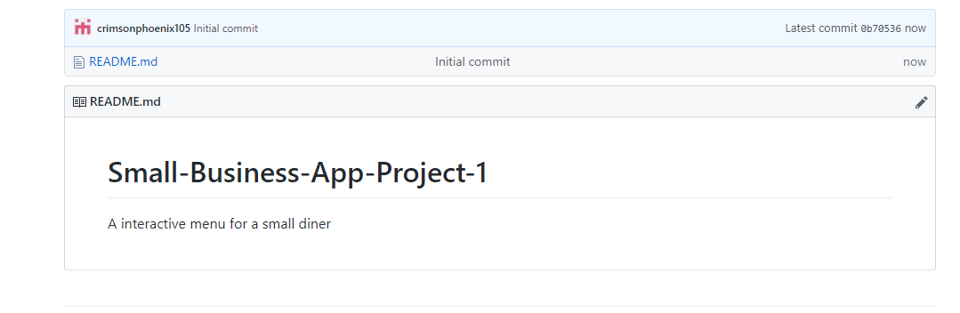

## Create a Branch

1. Review the information about Branching and answer the following questions:
2. **What is a branching? A way to work on different versions of a repository at one time**
3. **What is the default name of a branch in the Repository? Master**
4. **What is the purpose of using branches before placing them in the default branch? Experiment and make edits before commitment to master.**
5. Go to your new repository hello-world.
6. Click the drop down at the top of the file list that says branch: master.
7. Type a branch name, readme-edits, into the new branch text box.
8. Select the blue Create branch box or hit “Enter” on your keyboard.
9. **Take a screen capture**

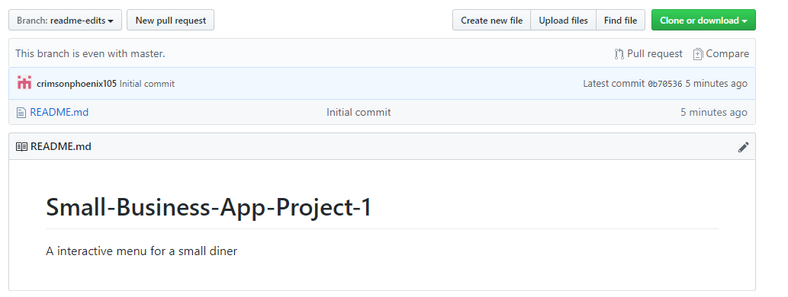

## Make and commit changes

1. Click the README.md file.
2. Click the pencil icon in the upper right corner of the file view to edit.
3. In the editor, write a bit about Project 1 requirements.
4. Write a commit message that describes your changes.
5. Click Commit changes button.

## Open a Pull Request

1. Review the Open a Pull Request instruction in the guide and answer the below questions:
2. **What is the purpose of Pull Request? To propose a change and requesting review and merge of your work into their branch.**
3. **What are the 2 color indicators of diffs (changes) in Pull Request? Green is for additions while red is for subtractions.**
4. Communicate with your project team and create a Pull Request for Project 1.
5. **Take a screen capture.**

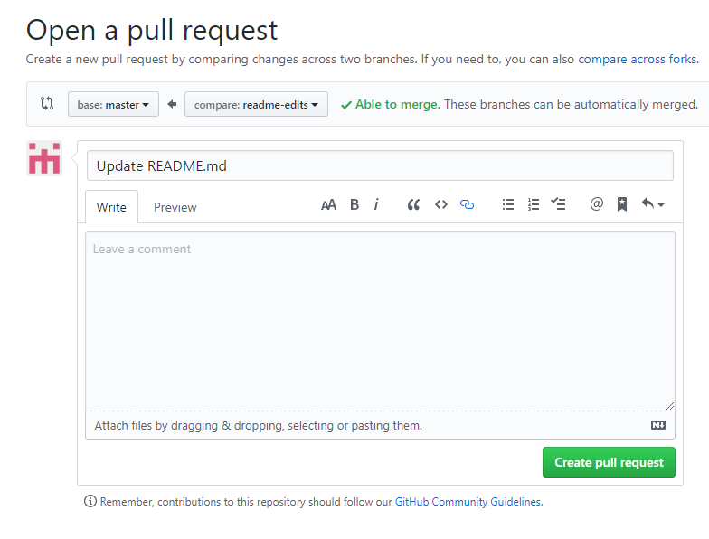

## Add Collaborators

1. Return to the repository you created in the first section of this assignment.
2. Click on the repository and click Settings
3. In Settings, click Collaborators and add your Project team members.
4. **Take a screen capture.**



## Submit work

1. Logout of GitHub and close the website.
2. Access Canvas assignment and submit assignment answers and screen captures.